Class III Name: .............................................................................
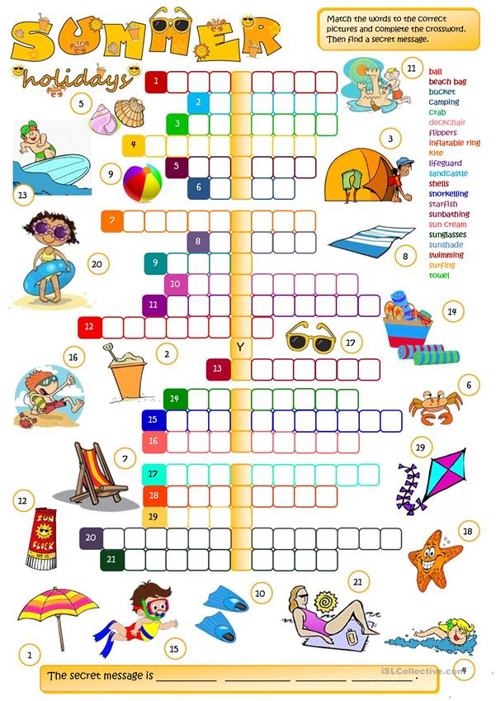

Name: …………………………………………………………………………………Class III Na 6!
- Dobierz dany zegarek do zapisanej godziny:
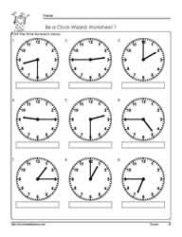
- It is half past two.
- It is quarter past nine.
- It is one o`clock.
- It is quarter past one.
- It is quarter to five.
- It is two o`clock.
- It is quarter to seven.
- It is quarter to five.
- It is half past eight.
- Połącz zapis godzin po angielsku z zapisem cyfrowym godzin:
- - 12. 20
- - 6. 35
- – 9. 30
- – 10. 00
- – 11. 40
- – 10. 59
- – 2. 15
- – 5. 15
- – 6. 40
- – 2. 45
- It is eleven o´clock.
1. 7:15
2. 3:15
3. 6:00
4. 4:30
5. 9:30
6. 12:30
7. 10:00
8. 7:45
9. 11:00
10. 5:15

- It is quarter past seven o´clock.
- It is quarter past three o´clock.
- It is half past twelve o´clock.
- It is quarter to eight o´clock.
- It is six o´clock.
- It is half past nine o´clock.
- It is ten o´clock.
- It is quarter past five o´clock.
- It is half past four o´clock.

- Zaznacz godziny na zegarach:

It is quarter past seven o´clock.

It is nine o´clock.

It is quarter to five o´clock.

It is half past
two o'clock.

It is twenty –five minutes past seven o´clock.

It is half past six o´clock.

It is eleven o´clock.

It is quarter past four o´clock.

It is half past twelve o'clock.

It is half past one o´clock.

Przypominam:
half past - połowa po (np. 6:30)
quarter past – kwadrans po (3:15)
quarter to- za kwadrans (6:45)

