Unit 7. Let’s travel | Imię |  | Klasa
Test 7 grupa A
 | Nazwisko

Rozumienie ze słuchu

- Narysuj wskazówki na każdym zegarze zgodnie z treścią nagrania.

1 2

3 4

Score |  | / 4

- Otocz pętlą ilustracje przedstawiające zapakowane przedmioty.

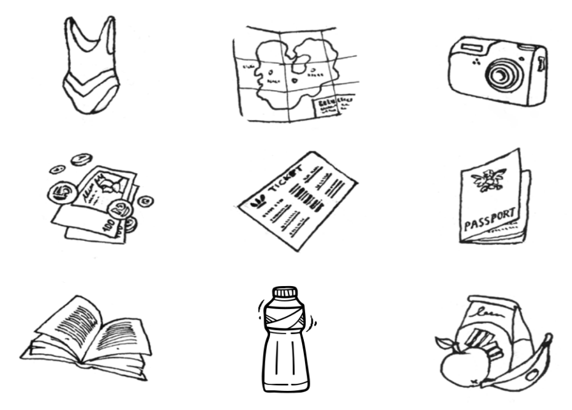

Score; ____

Rozumienie tekstu pisanego

- Do każdego zdania dopasuj właściwe ilustracje wpisując przy zdaniach litery.

We are going to the seaside.

Get your swimsuit!

We’re going by plane.

It’s half past nine.

Have you got your suitcase?

A. B. C. D. E.

Score |  | / 5

Tworzenie prostych wypowiedzi pisemnych

- Rozszyfruj i zapisz 3 zdania.

camels are pyramids river lots of there the ancient is long

1..............................................................................................

2..............................................................................................

3 .............................................................................................

Umiejętność komunikowania

- Ponumeruj zdania tak, aby powstał dialog.

Go back and get them. You must hurry.

Have you got the tickets?

Are we going to London by train?

No, I haven’t.

Yes, we are.

Score |  | / 5

*Zadanie dodatkowe: słownictwo, rozumienie tekstu pisanego

- Uzupełnij zdania wyrazami z ramki. Uwaga! Jeden wyraz jest podany dodatkowo i nie pasuje do żadnego zdania.

desert ancient holiday walls sunny ride

A lot of people go to Egypt on |  |  |  |  |  |  |  |  |  |  | . They go
by plane. You can |  |  |  |  |  |  |  | a camel in the Sahara
 |  |  | or sail on the river Nile. You can see the
pyramids with signs on the |  |  |  |  |  |  |  |  |  | or go to the
beach. It’s hot and |  |  |  |  |  |  |  |  | in Epypt. People love
their holidays there.
 |  |  |  |  |  |  |  |  |  |  | Score |  | / 5

