Vocabulary

- Write the missing letters to complete the words. Uzupełnij wyrazy brakującymi literami.

a | b | c | d | e
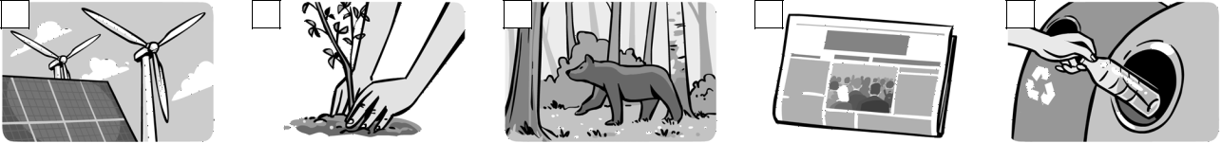

r _ _ _ _ _ _ _ _ |  |  | p _ _ _ _ | natural h _ _ _ _ _ _ n _ _ _ _ _ _ _ _ |  |  |  |  | r _ _ _ _ _ _ plastic
energy |  |  | a tree
f |  | g |  |  | h |  | i |  |  | j
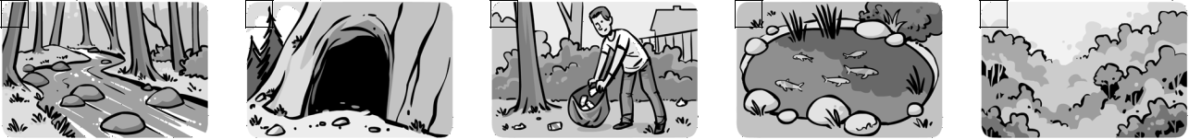

s _ _ _ _ _

c _ _ _

c _ _ _ _ up

p _ _ _

r _ _ _ _ _ _ _ _ _

Grammar‌

Score: ___ / 10

- Circle the correct option. Zakreśl odpowiednie wyrazy.

1 So far, he has written / wrote / had written four articles for the magazine.

2 Had they finished / Have they finished / Do they finish building the new power station yet?

3 It wasn’t a surprise for them because they have heard / were hearing / had heard about it before. 4 She have read / has read / had read a few books this year about renewable energy.
5 Before our holiday last summer, I had never been / have never been / was never in a cave.

Score: ___ / 5

- Complete the sentences. Use the verbs from the box either in the Present Perfect Simple or the Past Perfect Simple. Uzupełnij zdania czasownikami z ramki w czasie Present Perfect Simple lub Past Perfect Simple.

get move not start take turn

- The presentation _______________ when we arrived, so we didn’t miss anything.- past

- This meeting _______________ into a protest. I think we should go.- present

- They _______________ some action on pollution this year, and the air is already cleaner.- present

- That’s not important now because they _________ already _________ onto a different topic.- present

- The police arrived because some people _______________ onto the roof of the factory.- past

Extra Task‌

- Read the text. Fill gaps 1–4. Circle the correct option (a, b or c). Przeczytaj tekst. Wybierz poprawne uzupełnienie luk 1–4 (a, b lub c).

BE GREEN!

Our city (1) _____ a programme of recycling this year. Before then, people (2) _____ all their waste

into one bin, but now we segregate everything. At school, we (3) _____ about the environment many

times with our biology teacher, so we know a lot about the problem. In fact, my dad (4) _____ to do

something about it a few years ago, but nobody listened to him.

1 | a has introduced | b have introduced | c had introduced
2 | a has put | b have put | c had put
3 | a talks | b has talked | c have talked
4 | a has tried | b had tried | c have tried | Score: ___ / 4

