Short test unit 7: Hobbies and activities
- Label the pictures. The first letter is given.
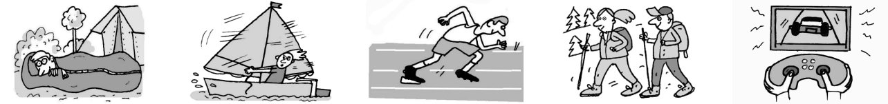

1 The boy is in 2 He likes 3 I like doing 4 They are 5 He is playing

a s__________ s__________. a__________. h__________. a v__________

b__________. g__________.
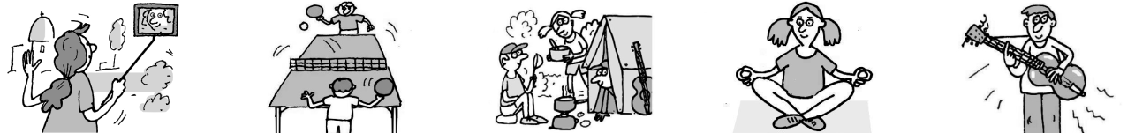

6 She is using 7 They are 8 Our hobby is 9 Her hobby is 10 He is

a s__________ playing c__________. y__________. playing the

s__________. t__________ g__________.

t__________.

Score: ___ / 10

- Fill the gaps to complete the following words.

1 | c _ m _ ra | 6 | p _ in _
2 | a _ ti _ e | 7 | e _ c _ ting
3 | cr _ ati _ e | 8 | un _ su _ l
4 | in _ tr _ ment | 9 | c _ ntrol _ er
5 | c _ es _ | 10 | _ ela _ ing

Score: ___ / 10

Extra Task

- Complete the text with the correct form of the words in the box.
relax paint brush create bore

My hobby is painting. I spend all my free time creating new pictures and designing posters. Some of my friends think it’s very (1) ____________________, but I love it. When I’m painting I don’t

think about school or my problems, so it’s really (2) ____________________. I love making new

things, so being original and (3) ____________________ is very important to me. I enter a different

world when I start to (4) ___________________. I can’t hear or see anything around me. I focus on the

(5) ____________________ in my hand and the detail in the painting I want to finish.

Score: ___ / 5

Short test unit 7: hobbies
- Label the pictures. The first letter is given.
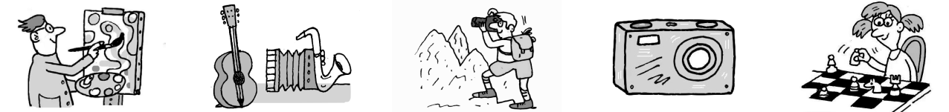

1 He is good 2 She plays 3 P__________ 4 This is my new 5 She likes

at a________. an i_________. is my hobby. c__________. playing

c__________.
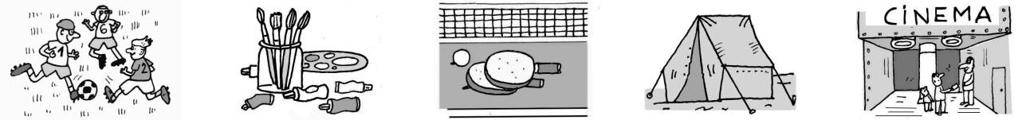

6 They love 7 These are 8 Table tennis 9 This is 10 We often

p__________ p_______ and is my h______. a t_________. g__________

f__________. b__________. to the cinema.

Score: ___ / 10

- Fill the gaps to complete the following words.

1 | ho _ bi _ s | 6 | in _ er _ sted _ n
2 | be r _ all _ into | 7 | m _ s _ c
3 | w _ ek _ nd | 8 | in _ ol _ ed _ n
4 | t _ e _ tre | 9 | _ o _th | club
5 | _ een _ n | 10 | _ ra _ y | a _ out

Score: ___ / 10

Extra Task

- Complete the text with the correct form of the words in the box.
- fan keen interest crazy involve

My brother loves everything to do with football. He is absolutely (1) ____________________ about

it and he spends all his free time playing or watching matches. He is (2) ____________________

in organising the local league and every Saturday he goes to different villages to watch a game.

His favourite team is Arsenal. He has been a (3) ____________________ since he was 5 years old.

I’m also (4) ____________________ on football, but not as much as him. I’m (5) ___________________

in other sports too, like sailing and volleyball.

Score: ___ / 5

