Short Test 7 a
Name

Class

Score | / 15

- Podpisz sporty przedstawione na rysunkach 1–6.
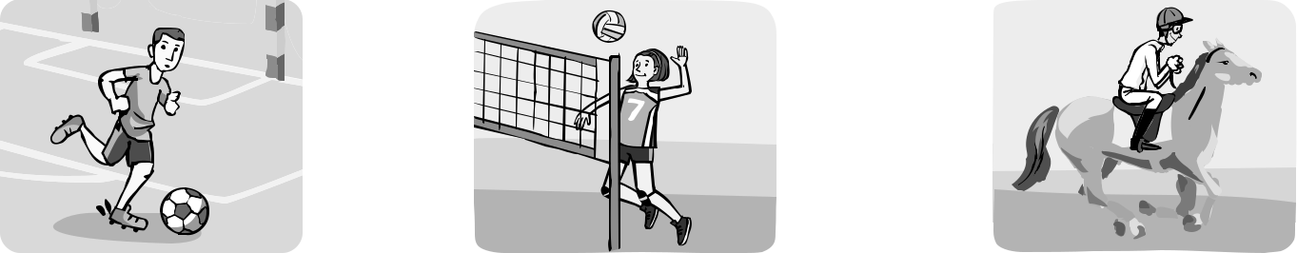

₁ football ₂ ₃
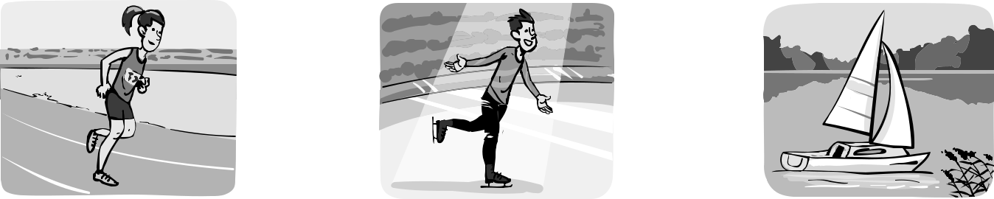

4 5 6

Score: ___ / 5

- W zdaniach 1–6 wstaw czasownik play lub go w odpowiedniej formie.

1 | John |  |  |  | goes |  |  |  | skiing every winter.
2 | We don’t |  |  |  |  |  |  |  |  |  |  | ice hockey in summer.
3 | Kelly doesn’t |  |  |  |  |  |  |  |  |  |  |  |  | football.
4 | I often |  |  |  |  |  |  |  |  |  | cycling in summer.
5 | Does Peter |  |  |  |  |  |  |  |  |  |  |  | running every morning?
6 | Emily |  |  |  |  |  |  |  |  | horse riding at the weekend.

Score: ___ / 5

- W zdaniach 1–6 zaznacz strzałką ↓ miejsce podanego przysłówka częstotliwości.

1 | I am ↓ tired after school. |  |  |  |  |  |  |  |  | often
2 | Kelly | wakes |  | up | at |  | 7.00 in | the | morning. | always
3 | My | dad | and |  | I | go | sailing | in | summer. | usually
4 | Tom | is | late | for |  | school. |  |  |  | never
5 | We | play | basketball |  |  |  | at the | weekend. |  | sometimes
6 | Frank’s answers |  |  |  | are |  | stupid. |  |  | often

Score: ___ / 5

Junior Explorer 4 Short Test 7 a PHOTOCOPIABLE © Copyright by Nowa Era Sp. z o.o., 2017

Short Test 7 b
Name

Class

Score | / 15

- Uzupełnij luki w zdaniach 1–8 wyrazami z ramki.

 |  |  |  |  |  | trains tracksuit skates |  |  |  |  |  |  |  | coach |  | bat fans suit team
1 | Mr Black is my |  |  |  |  |  | coach |  |  |  |  | . He teaches me tennis.
2 | A |  |  |  |  |  | is a long stick used in baseball.
3 | A |  |  |  |  |  | is a group of people that play a sport together.
4 | I have got a pink swimming |  |  |  |  |  |  |  |  |  |  |  |  | for swimming.
5 | Susan loves ice skating. Her ice |  |  |  |  |  |  |  |  |  |  |  |  |  | are white.
6 | When it is cold outside, I run in my |  |  |  |  |  |  |  |  |  |  |  |  |  |  | .
7 |  |  |  |  |  | are people who like some sports very much.
8 | My team |  |  |  |  |  |  |  | outdoors in summer.

Score: ___ / 7

- Przeczytaj zdania 1–8 i zaznacz poprawną odpowiedź (a, b lub c).

- We never go to school … Sunday.

a in b on c at

- Emily has got an English lesson … lunch.

a every b before c at

- … school we go home.

a After b At c Before

- Maths lesson finishes … 1 p.m.

a in b on c at

- Helen’s birthday is … May.

a in b on c at

- My brother plays computer games … day.

a in b after c every

- … every basketball match there is usually a great party.

a Every b After c At

- What do you do … Monday mornings?

a on b before c in

- We often play beach volleyball … summer.

a at b on c in

Score: ___ / 8

