Unit 5 Short Test A Group 1

Vocabulary 1: family

Grammar 1: PresFamily, prezent pent Simple, Present Continuous & stative verbs
Family, Present Simple, Present Continuous
Vocabulary‌

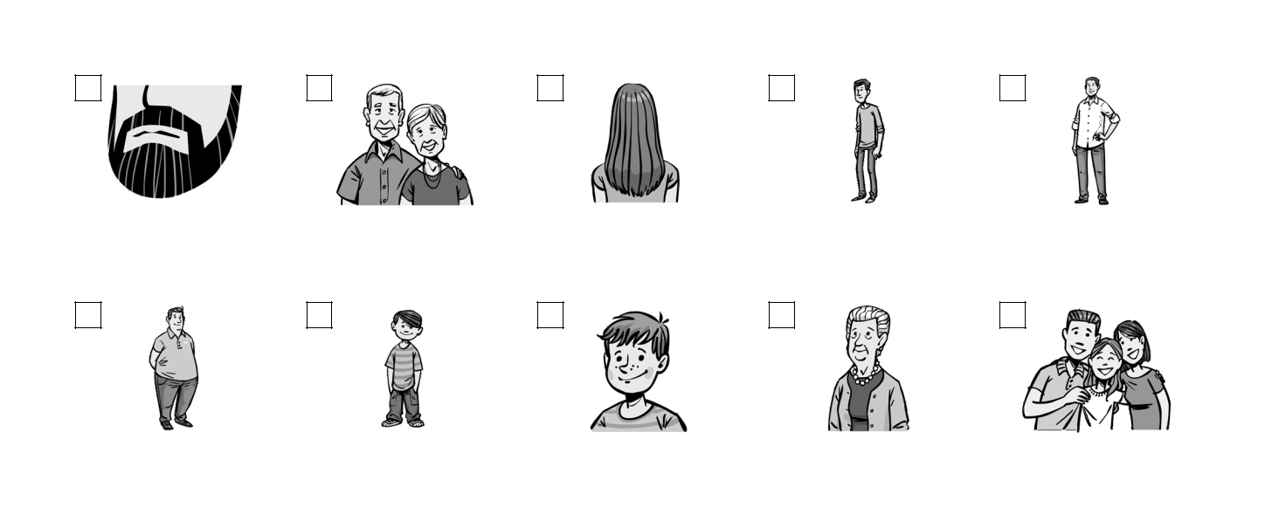

- Label pictures a–j.

a | b | c | d | e

b_________ |  | an e________ |  |  | s_________ hair |  |  | a s______ man |  |  | He is t______ .
 |  | couple
f |  |  | g |  |  | h |  |  | i |  |  | j

He is o_________ . a y__________ boy

s____________ hair

My g___________ .

They are

h____________ .

Score: ___ / 10

Grammar‌

- Circle the correct option.

- She’s wears / wore / is wearing a white dress today.

- They looks / look / looked relaxed in this photo.

- He often is visiting / visits / visit his cousins at the weekend.

- Look at this one. My nephew is standing / stands / stood in the background here.

5 My uncle had / has / is having a long beard at the moment. Score: ___ / 5

- Complete the sentences. Use either the Present Simple form, the Present Continuous form or the infinitive.

look have read sit tell

- She _________________ a lot of aunts and uncles. They all live in different places.

- Can you _________________ me when the concert starts?

- Don’t you agree that he _________________ like his grandfather?

- In this photo, he ___________________ in the foreground.

5 My aunt _________________ a story to my brother at the moment. Score: ___ / 5

Extra Task‌

4 Read the text and look at the picture. Fill each of the gaps (1–4) with one word.

This is a photo of me and my family. That’s me in the
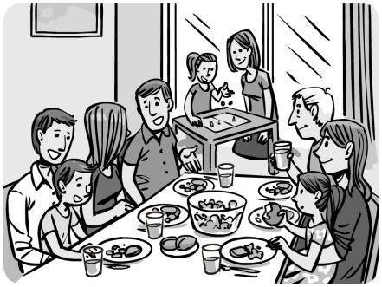

(1) _______________ , sitting at the table with my mum.

The man with the grey hair, sitting on our (2) _______________ ,

is my uncle Dan. My dad is (3) _______________ on the other

side of the table with my brother. You can see my aunt and

my cousin playing a game in the background, and there’s a

window (4) _______________ them. My other uncle and his

wife are also at the table.

