Short Test 6a
Name

Class

Score | / 15

- Podpisz rysunki 1–6. Uwaga! Liczba kresek odpowiada liczbie liter, które musisz wpisać.
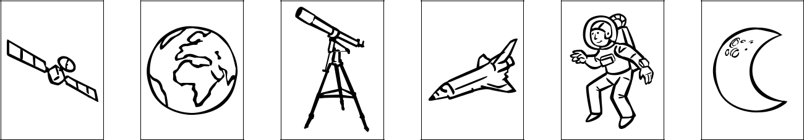

s a t e l l i t e _ a _ t _ _ e _ _ s _ _ p _ _ _ a_ e s _ _ tt _ _ _ _ t _ _ n _ _ t _ _ _ n

Score: _ / 5

- Uzupełnij zdania 1–6 wyrazami z ramki.

astronomer planet universe solar sky star

1 A(n) astronomer knows a lot about stars and planets

- There are eight planets in the ____________________ system.

- When you see a shootin ____________________ you should make a wish.

- All the stars and planets make up the ____________________.

- When there are no clouds, the ____________________ is clear.

- Mercury is the smallest ____________________. It is also the closest to the sun.

Score: _ / 5

- Z podanych wyrazów utwórz poprawne zdania.

- you / laptop / show me / will / your new?

Will you show me your new laptop?______________________

- not be / long / winter / will / and cold

____________________________________________________

- next Sunday / there / a full / will be / moon

____________________________________________________

- at the weekend / will / visit / our grandparents / us?

____________________________________________________

- with us / will / Ann / not go / to the cinema

____________________________________________________

- lend me / your / will / you / new bike?

____________________________________________________

Score: _ / 5

